Homework – due 23rd of January
Spellings:
- Promise
- Understand
- Popular
- Pressure
- Private
- Interesting
- Famous
- Occasion
- Government
- Difficult
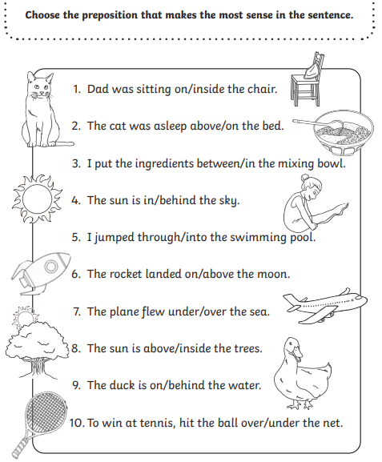

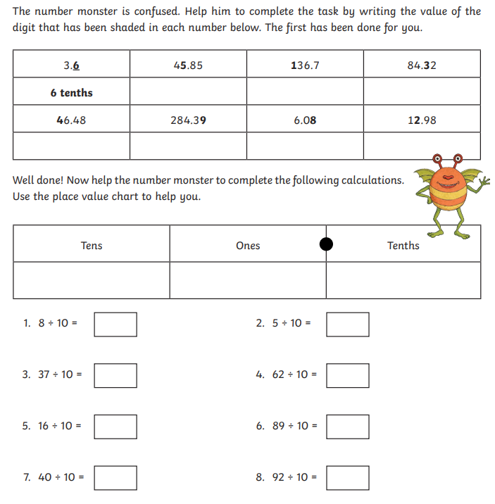

Handwriting:
Listen to the recording on the school website and practice your handwriting below:
……………………………………………………………………………………………………………………………………………………………………………………………………………………………………………………………………………………………………………………………………………………………………………………………………………………………………………………………………
Remember to go on TTRS and read every day!

