key
because
gnome
knight
night
know
sign
design
wrong
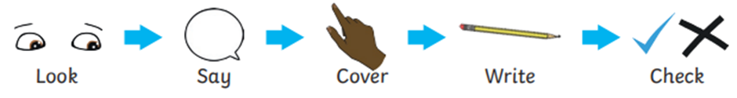
Write a sentence using at least two of the words.

English – can you circle the adjectives?
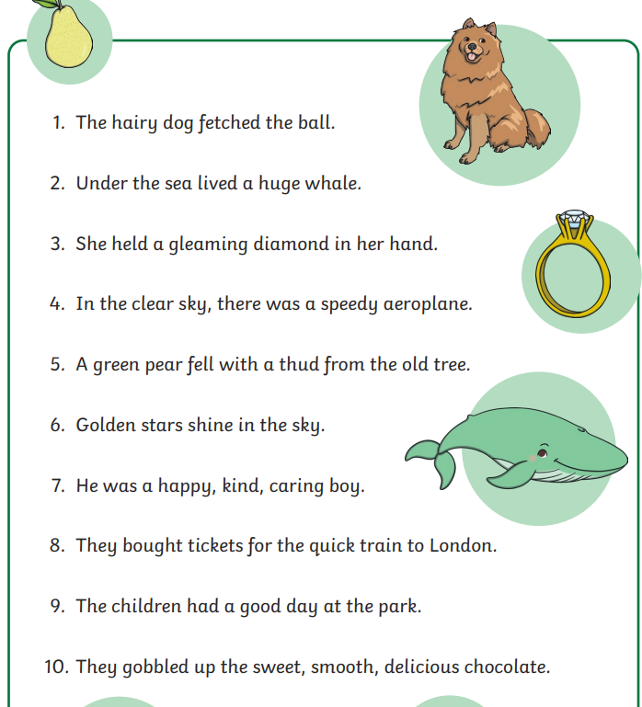
Maths
Can you add the coins? How much money in the jar?



