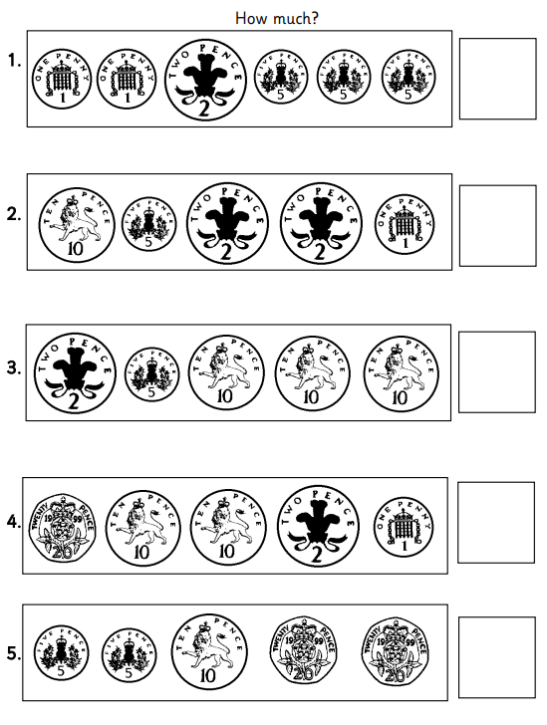
Maths – can you add the coins
You will need to be solid in your addition. Practice counting in 2’s, 5’s and 10’s

In ten’s: 32, ____, _____, _____, _____, _____
In five’s: 40, ____, _____, ______, _____, _____
In two’s: 12, _____, _____, ______, ______, _____


wrap
wrapper
gnasher
wrote
wriggle
gnat
liked
scared
danced

Write a sentence using at least two of the words.

English – can you add commas in a list correctly
Example: My favourite colours are pink, purple, blue and orange.

1. You need flour eggs sugar and butter to make a cake.
_________________________________________________________________________________
2. Gemma owns a, cat a, dog a, parrot and a hamster.
____________________________________________________________________________________
3. Zac plays hockey on Mondays Wednesdays, Saturdays.
________________________________________________________________________________________
4. They bought hot dogs ice cream jelly and crisps for the party
________________________________________________________________________________________
5. My bag holds a pencil case two books my lunch and a water bottle.
____________________________________________________________________________________
Challenge: write your own sentence using commas in a list.
__________________________________________________________________________________________________________________________________________________________________________________________________________________________________________________________________________________________________

