Maths – can you add in 2’s and 5’s
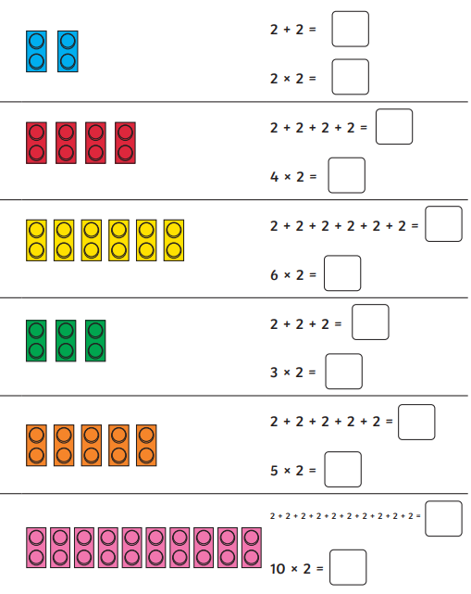

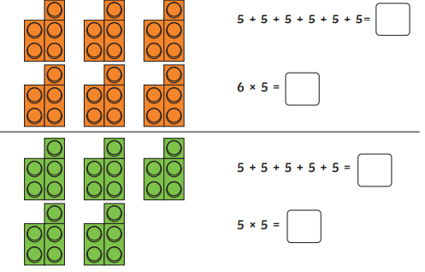


liked
being
freeing
white
safest
latest
nicest
bravest
Scaring

Write a sentence using at least two of the words.

English – Can you match the adjectives to the nouns to make it an expanded noun phrase?
When you have matched them can you put 5 of them into a full sentence.
Don’t forget your capital letters, commas and full stops.
Example: At the seaside, we all ate a delicious, cold ice cream.
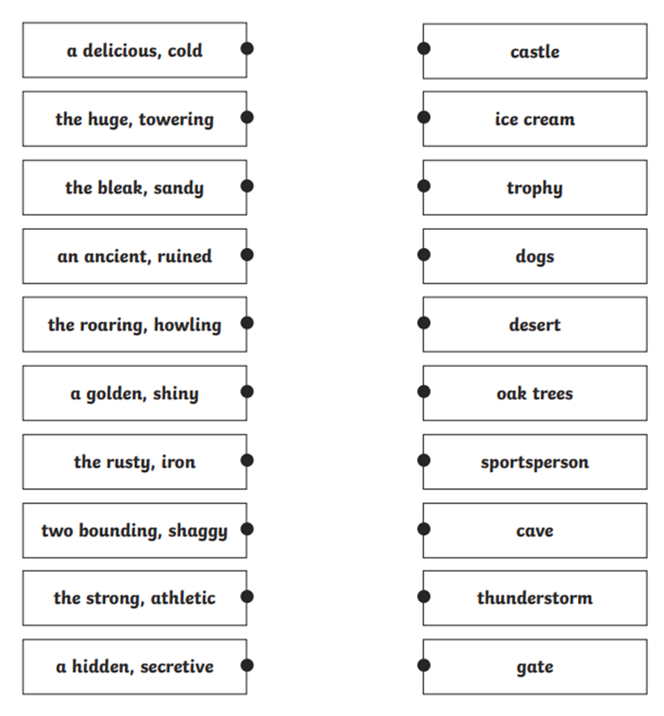
Remember: expanded nouns are 2 adjectives before the noun.

