Spelling’s homework

Digging
Warning
Firstly
people
again
father
squatting
watches
wagging


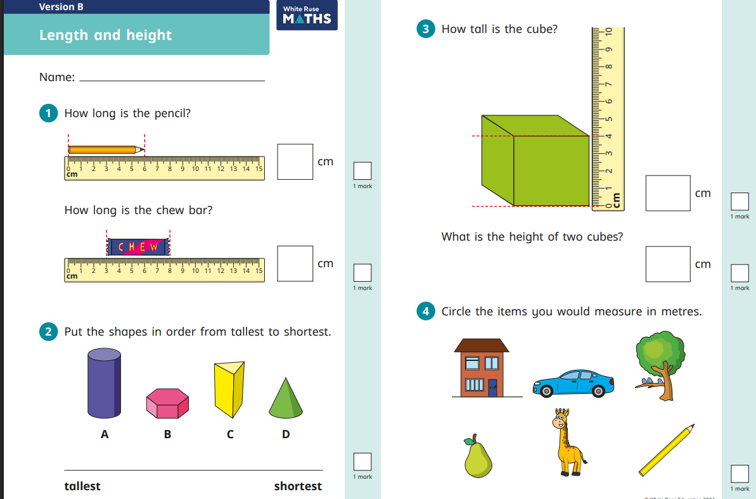
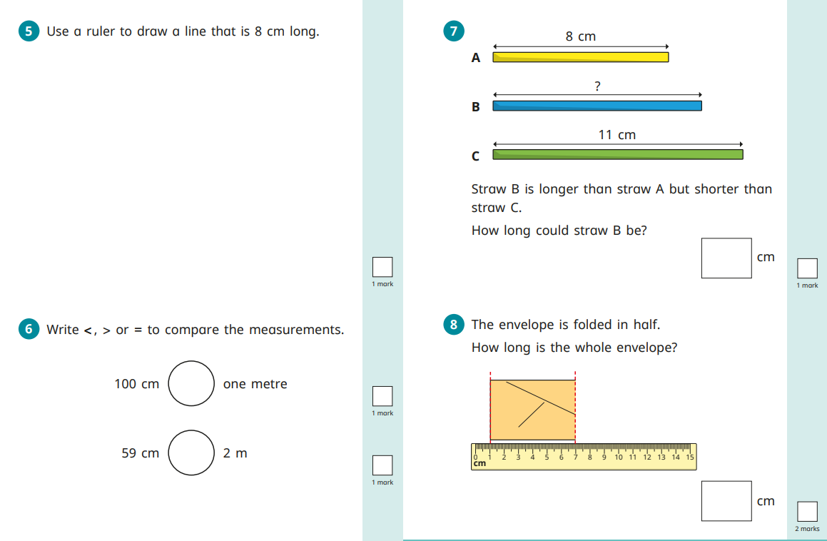
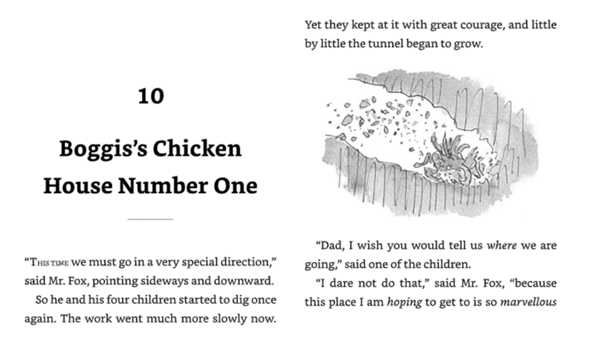
- Who is digging in the tunnel?

- Which direction does Mr Fox tell them to dig?

- How is the digging going now?
☐ Fast
☐ Slow
- Who asks Mr Fox where they are going?

- Does Mr Fox tell them?
☐ Yes
☐ No

- Why do you think Mr Fox will not tell the children where they are going?

- Mr Fox says the place is “marvellous.”
What does “marvellous” mean?
☐ Terrible
☐ Wonderful
☐ Ordinary

🎨 Draw and Write
Draw a picture of Mr Fox and his children digging in the tunnel.



