Year 6 Homework 5
- Go on time table rockstars for 10 minutes.
- Read your reading book.
- Practice step 6 spellings (word document attached below)
- Complete your handwriting transcription
- Answer the questions below

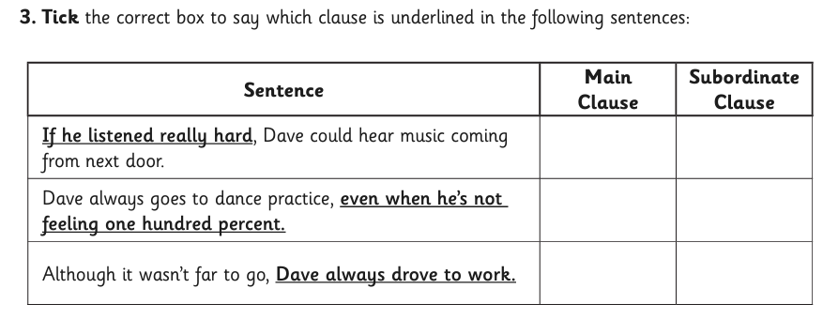

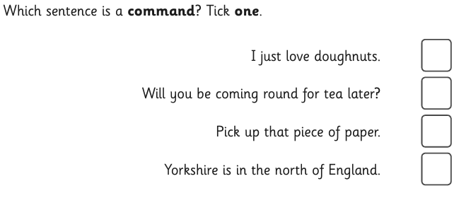

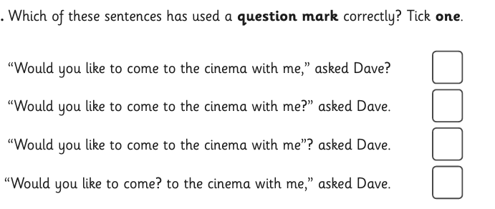

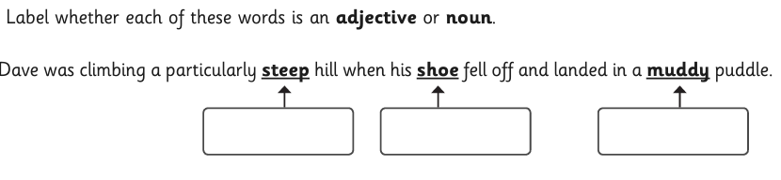
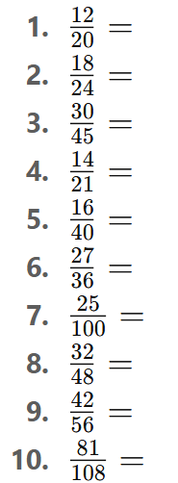
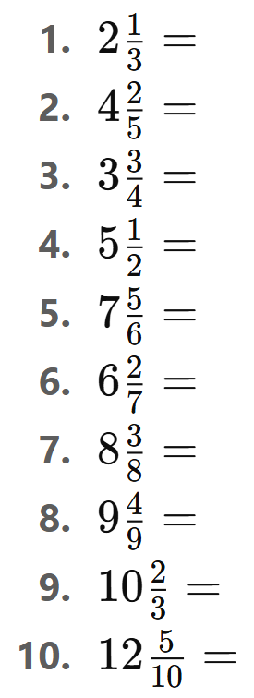
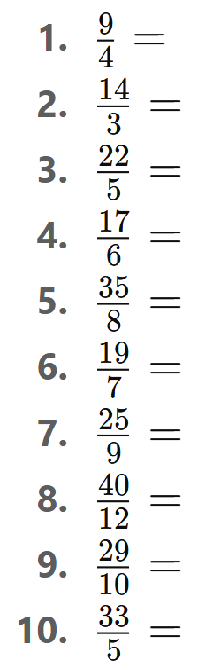
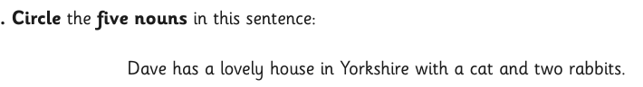
Simplify these fractions
Convert the mixed Numbers to Improper fractions
Convert the Improper Fractions to Mixed Numbers

