Year 6 Homework 6
- Go on time table rockstars for 10 minutes.
- Read your reading book.
- Practice step 7 spellings (word document attached below)
- Complete your handwriting transcription
- Answer the questions below

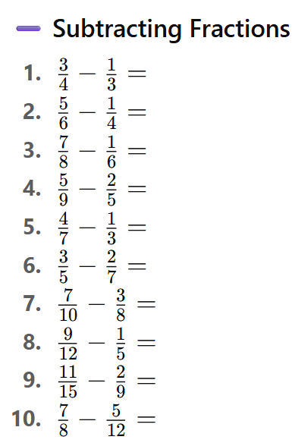
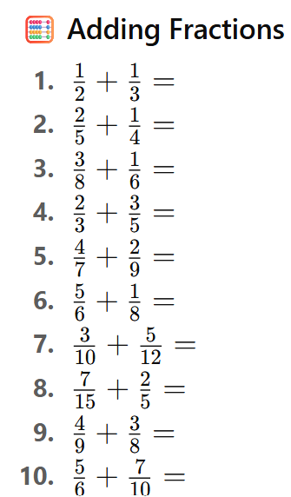

Order the fractions from small - big
Order the fractions from small - big

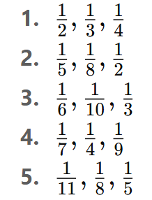
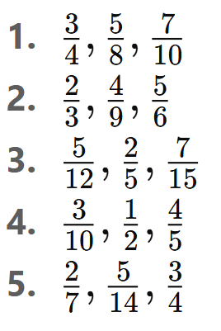

- Choose the correct form of the verb: She _______ her homework before dinner.
(a) done (b) did (c) doing
- Add a comma in the correct place: After lunch we went to the park and played football.
- Which sentence is written in the past tense?
(a) I am eating lunch. (b) I eat lunch. (c) I ate lunch.
- Circle the relative pronoun in this sentence: The man who lives next door is a doctor.
- Rewrite this sentence using inverted commas correctly:
The teacher said we will start the test now.
- Which word is an adverb?
(a) slowly (b) table (c) bright
- Write the plural of the word child.
- Identify the main clause in this sentence:
Although it was raining, we still went outside.
- Which word is a preposition?
(a) under (b) run (c) dog
- Add an apostrophe to show possession:
The books cover was torn.
- Choose the correct synonym for angry:
(a) calm (b) furious (c) gentle
- Which sentence uses formal language?
(a) I’m gonna go now. (b) I am going to leave now.
- Tick the sentence that is punctuated correctly:
(a) I like apples oranges and bananas.
(b) I like apples, oranges, and bananas.
- Identify the subject of this sentence:
The dog chased the ball across the field.
- Change this sentence to passive voice:
The chef cooked a delicious meal.
- Choose the correct homophone:
I can’t wait to see what you got for _______ birthday.
(a) you’re (b) your
- Write a complex sentence that includes the conjunction because.
- Which sentence uses a modal verb?
(a) I will finish my homework later. (b) I finished my homework.
- Add the missing punctuation:
Wow that was amazing
- Identify the adjective in this sentence:
The tall tree swayed gently in the wind.


