Homework – due 16th January
Spellings – test 16th January
- Believe
- Because
- Friend
- Separate
- Special
- Different
- School
- Thought
- Accidentally
- Surprise
In addition to our weekly spelling test, we will be having a weekly grammar test to work on our grammar. Next week our grammar focus will be on pronouns. Pronouns are words that can be used in the place of nouns. EG: I, he, you, she, we. Practice this below:
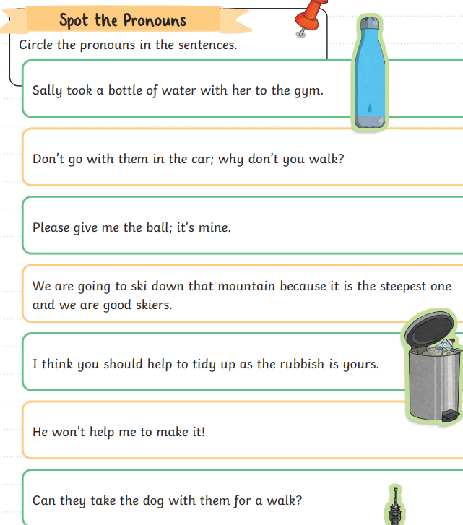

Handwriting
Listen to the recording on the school website and practice your handwriting below:
………………………………………………………………………………………………………………………………………………………………………………………………………………………………………………………………………………………………………………………………………
Times tables + reading : Remember to practice your times tables and read everyday!



